Acceptance tests   
Acme-Rookies 1.0

|  |  |
| --- | --- |
| **Development team** | |
| **Identifier** | G30 |
| **Members** | Burdallo Narváez, Alba  Cabello López, Tomás  De la Cruz Charro, Juan Antonio  Muñiz Peña, Jose Manuel  Picón Mora, Antonio  Recio Real, Manuel |
| **Testing team** | |
| **Identifier** | Write the identification of your testing team, e.g., “G89”. |
| **Members** | List the members of your testing team, e.g. “Rus, Elena; Pi, Juan; Luz, Pedro”. |
| **Indexing data** | |
| **Test designers** | De la Cruz Charro, Juan Antonio |
| **Testers** | List the people who have conducted the tests, e.g., “Rus, Elena”. |
| **Notes** | Add notes if necessary. |

Table of contents

Use case #23.1 List social profiles 3

Use case #23.1 Create a social profile 4

Use case #23.1 Show a social profile 5

Use case #23.1 Edit a social profile 6

Use case #23.1 Delete a social profile 7

Use case #23.2 List your Messages 8

Use case #23.2 Show a message 9

Use case #23.2 Delete a message 10

Use case #23.2 Send a message 11

Use case #24.1 Broadcast message: Security breach 13

Use case #24.2 and 24.3 Ban an actor 15

Use case #24.4 Unban an actor 17

Additional tests 18

# Use case #23.1 List social profiles

Description

An actor can list his or her social profiles

Access

Main Menu > Login > Login as hacker1/hacker1 > Social Profiles > List social profiles

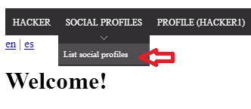

|  |  |
| --- | --- |
| **Test 1** | |
| **Description** | An actor can list his or her social profiles. |
| **Expected** | The system must return to the list of social profiles, it must display the following social profiles:  Nick: UserTest  Social network: Twitter  Link: http://www.twitter.com |
| **Outcome** | Describe what you’ve got when you performed this test. Add screenshots if necessary. Please, make sure that your description is enough for a developer to repeat what you’ve done, so that he or she can correct the problem. For instance, “Option `Register’ in the main menu was not properly translated into Spanish. The system displays it in English”. |
| **Notes** | Add notes if necessary. |

# Use case #23.1 Create a social profile

Description

A logged actor can create social profiles.

Access

Main Menu > Login > Login as hacker1/hacker1 > Social Profiles > List social profile > New Profile

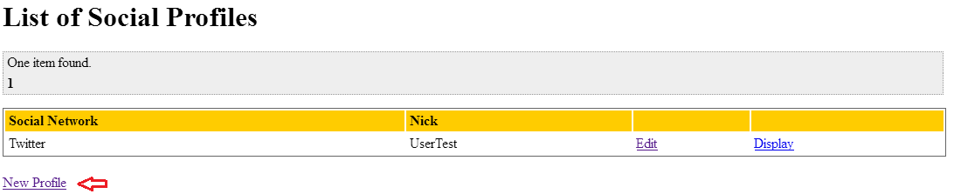

|  |  |
| --- | --- |
| **Test 1** | |
| **Description** | An actor can create social profiles, please use the following data:  Nick: Testing user  Social network: Twitter  Link: http://www.twitter.com |
| **Expected** | The system must return to the list of social profiles, and show the new social profile created. |
| **Outcome** | Describe what you’ve got when you performed this test. Add screenshots if necessary. Please, make sure that your description is enough for a developer to repeat what you’ve done, so that he or she can correct the problem. For instance, “Option `Register’ in the main menu was not properly translated into Spanish. The system displays it in English”. |
| **Notes** | Add notes if necessary. |

# Use case #23.1 Show a social profile

Description

A social profile can be shown to his or her owner.

Access

Main Menu > Login > Login as hacker1/hacker1 > Social Profiles > List social profiles > Show

|  |  |
| --- | --- |
| **Test 1** | |
| **Description** | A social profile can be shown to his or her owner. Please show the first social profile of the actor. |
| **Expected** | The system must return a view with all the attributes and values of the social profile. |
| **Outcome** | Describe what you’ve got when you performed this test. Add screenshots if necessary. Please, make sure that your description is enough for a developer to repeat what you’ve done, so that he or she can correct the problem. For instance, “Option `Register’ in the main menu was not properly translated into Spanish. The system displays it in English”. |
| **Notes** | Add notes if necessary. |

# Use case #23.1 Edit a social profile

Description

An actor can edit one of his or her social profiles.

Access

Main Menu > Login > Login as hacker1/hacker1 > Social Profiles > List social profiles > Edit

|  |  |
| --- | --- |
| **Test 1** | |
| **Description** | An actor can edit social profiles, please edit the first social profile using the following data:  Username: TestEdit  Social network: Facebook  Link: http://www.facebook.com |
| **Expected** | The system must return to the list of social profiles, and show the edited social profile; |
| **Outcome** | Describe what you’ve got when you performed this test. Add screenshots if necessary. Please, make sure that your description is enough for a developer to repeat what you’ve done, so that he or she can correct the problem. For instance, “Option `Register’ in the main menu was not properly translated into Spanish. The system displays it in English”. |
| **Notes** | Add notes if necessary. |

# Use case #23.1 Delete a social profile

Description

A social profile can be deleted by his or her owner.

Access

Main Menu > Login > Login as hacker1/hacker1 > Social Profiles > List social profiles > Delete

|  |  |
| --- | --- |
| **Test 1** | |
| **Description** | An actor can delete one of his or her social profiles. In this test, please delete the first social profile of hacker1. |
| **Expected** | The system must return to the list of social profiles, and it must not show the social profile deleted. |
| **Outcome** | Describe what you’ve got when you performed this test. Add screenshots if necessary. Please, make sure that your description is enough for a developer to repeat what you’ve done, so that he or she can correct the problem. For instance, “Option `Register’ in the main menu was not properly translated into Spanish. The system displays it in English”. |
| **Notes** | Add notes if necessary. |

# Use case #23.2 List your Messages

Description

A logged actor can list his or her messages by clicking in the link at the main menu.

Access

Main Menu > Login > Login as company1/ company1 > Main Menu > Messages > Show your Messages > Display the list of messages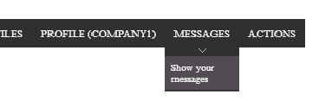

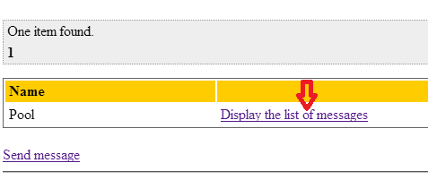

Tests

|  |  |
| --- | --- |
| **Test 1** | |
| **Description** | A logged actor can list his or her messages by clicking in the link at the main menu. |
| **Expected** | The system must return a table with all the messages of the company. |
| **Outcome** | Describe what you’ve got when you performed this test. Add screenshots if necessary. Please, make sure that your description is enough for a developer to repeat what you’ve done, so that he or she can correct the problem. For instance, “Option `Register’ in the main menu was not properly translated into Spanish. The system displays it in English”. |
| **Notes** | Add notes if necessary. |

# Use case #23.2 Show a message

Description

A logged actor can show a message of his or her list.

Access

Main Menu > Login > Login as company1/ company1 > Main Menu > Messages > Show your Messages > Display the list of messages > Show link on the message

Tests

|  |  |
| --- | --- |
| **Test 1** | |
| **Description** | A logged actor can show a message of his or her list. |
| **Expected** | The system must return a page with all the attributes and values of the message. |
| **Outcome** | Describe what you’ve got when you performed this test. Add screenshots if necessary. Please, make sure that your description is enough for a developer to repeat what you’ve done, so that he or she can correct the problem. For instance, “Option `Register’ in the main menu was not properly translated into Spanish. The system displays it in English”. |
| **Notes** | Add notes if necessary. |

# Use case #23.2 Delete a message

Description

A logged actor can delete a message of his or her list. He or she must delete it twice to finally delete it from the system (the first delete just add the tag “DELETED” to the message).

Access

Main Menu > Login > Login as company1/ company1 > Main Menu > Messages > Show your Messages > Display the list of messages > Show on the message > Delete >Display the list of messages > Show on the same message > Delete

Tests

|  |  |
| --- | --- |
| **Test 1** | |
| **Description** | A logged actor can delete a message of his or her list. |
| **Expected** | First, the system must return to the “Show Messages” view, and the message must have the tag “DELETED”. Once we press again the delete link, the message must be deleted from the database. |
| **Outcome** | Describe what you’ve got when you performed this test. Add screenshots if necessary. Please, make sure that your description is enough for a developer to repeat what you’ve done, so that he or she can correct the problem. For instance, “Option `Register’ in the main menu was not properly translated into Spanish. The system displays it in English”. |
| **Notes** | Add notes if necessary. |

# Use case #23.2 Send a message

Description

A logged actor can send a message to another actor. In this case we are going to send a valid message.

Access

Main Menu > Login > Login as company1/ company1 > Main Menu > Messages > Show Messages > Send message > Send

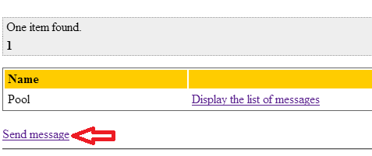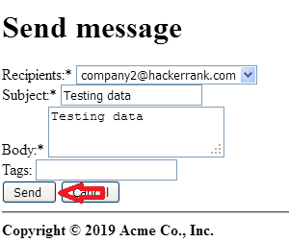

|  |  |
| --- | --- |
| **Test 1** | |
| **Description** | A logged actor can send a message. The form must be filled with the following data:  Recipient: [company2@hackerrank.com](mailto:company2@hackerrank.com)  Subject: Testing data  Body: Testing data  Tags: Intentionally blank, to also check it can be null  Then press the send button |
| **Expected** | The system must return to the list of messages and show the new message at the bottom of the list. |
| **Outcome** | Describe what you’ve got when you performed this test. Add screenshots if necessary. Please, make sure that your description is enough for a developer to repeat what you’ve done, so that he or she can correct the problem. For instance, “Option `Register’ in the main menu was not properly translated into Spanish. The system displays it in English”. |
| **Notes** | Add notes if necessary. |

|  |  |
| --- | --- |
| **Test 2** | |
| **Description** | A logged actor can send a message. The form must be filled with the following data:  Recipient: [company2@hackerrank.com](mailto:company2@hackerrank.com)  Tags: Intentionally blank, to check it can´t be null  Body: Testing data  Tags: TEST, MESSAGE, TESTING  Then press the send button |
| **Expected** | The system must return to the “send message” form, and inform that the message couldn´t be sent. |
| **Outcome** | Describe what you’ve got when you performed this test. Add screenshots if necessary. Please, make sure that your description is enough for a developer to repeat what you’ve done, so that he or she can correct the problem. For instance, “Option `Register’ in the main menu was not properly translated into Spanish. The system displays it in English”. |
| **Notes** | Add notes if necessary. |

# Use case #24.1 Broadcast message: Security breach

Description

An administrator can inform of a security breach on the system. Checking that we also check the broadcast message use case.

Access

Main Menu > Login > (Login as admin/admin) > Main Menu > Messages > Show Messages > Inform of a security breach > Send to everyone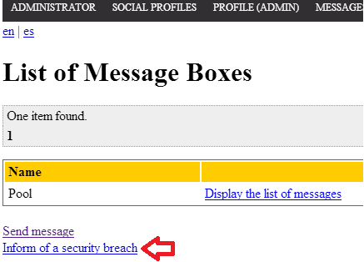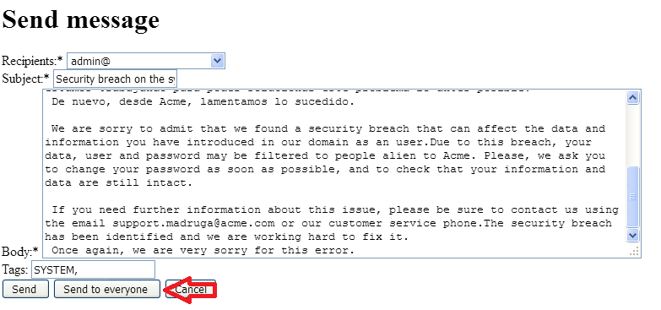

|  |  |
| --- | --- |
| **Test 1** | |
| **Description** | A logged actor can send a message. The form must be filled with the following data:  Recipient: This field is irrelevant; we are going to send the message to everyone.  Subject: Security breach on the system.  Body: The predefined security breach message.  Tags: SYSTEM, BREACH  Then press the “send to everyone” button |
| **Expected** | The system must return to the list of messages and show the messages sent at the bottom of the list, one for every user. |
| **Outcome** | Describe what you’ve got when you performed this test. Add screenshots if necessary. Please, make sure that your description is enough for a developer to repeat what you’ve done, so that he or she can correct the problem. For instance, “Option `Register’ in the main menu was not properly translated into Spanish. The system displays it in English”. |
| **Notes** | Add notes if necessary. |

# Use case #24.2 and 24.3 Ban an actor

Description

An administrator can ban a suspicious actor.

Access

Main Menu > Login > Login as admin/admin > Main Menu > Manage bans > Execute spam process > ban actor Provider3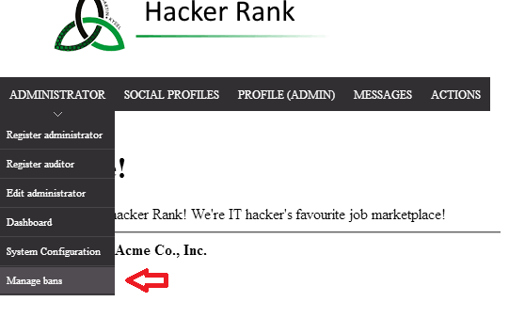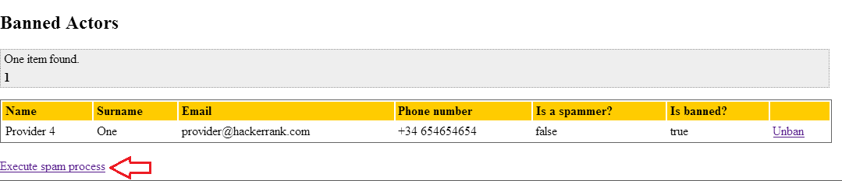

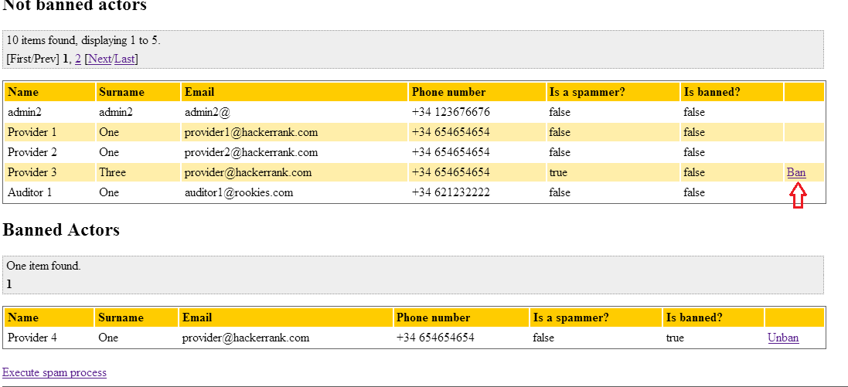

|  |  |
| --- | --- |
| **Test 1** | |
| **Description** | An administrator can ban actors. In this test, the actor provider3 must be banned |
| **Expected** | The system must return to the list of actors, the actor provider3 is now banned, the ban button does not appear. |
| **Outcome** | Describe what you’ve got when you performed this test. Add screenshots if necessary. Please, make sure that your description is enough for a developer to repeat what you’ve done, so that he or she can correct the problem. For instance, “Option `Register’ in the main menu was not properly translated into Spanish. The system displays it in English”. |
| **Notes** | Add notes if necessary. |

# Use case #24.4 Unban an actor

Description

An administrator can unban a banned actor.

Access

Main Menu > Login > Login as admin/admin > Main Menu > Manage bans > unban actor Provider4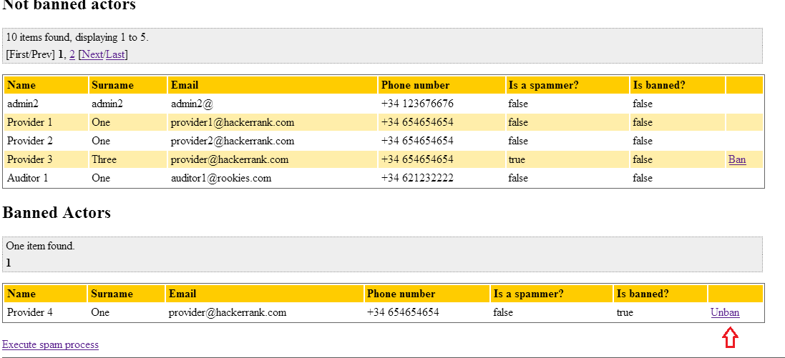

|  |  |
| --- | --- |
| **Test 1** | |
| **Description** | An administrator can unban actors. In this test, the first actor that appears in the list must be unbanned. |
| **Expected** | The system must return to the list of actors, the first actor now is unbanned, the unban button does not appear |
| **Outcome** | Describe what you’ve got when you performed this test. Add screenshots if necessary. Please, make sure that your description is enough for a developer to repeat what you’ve done, so that he or she can correct the problem. For instance, “Option `Register’ in the main menu was not properly translated into Spanish. The system displays it in English”. |
| **Notes** | Add notes if necessary. |

# Additional tests

Intentionally blank.